An Enhanced Decision Support Model using weight based correlation and regression with data classifiers for heart disease prediction

Abstract - Data analytics and classification play a substantial role in prediction and data exploration. Data classification provides the way for discovering various patterns and relationship from the identified data. In this paper, predictive performance and risk factor analysis has been made using various classification algorithms such as Decision Trees, Random Forest, Neural Network, Support Vector machines, Bayesian networks and Decision stump. They have been used up to explore the predictive nature and patterns in medical data. Dataset from the UCI machine learning repository and real dataset from a hospital study has been used for predictive analysis and determination of statistical performance. The risk factors are determined using weight based on correlation, and regression analysis. Experimental results shows that determination of predictive analysis using Bayesian network algorithm provides the highest accuracy level of about 89.63% and with precision and recall to be 80.50% , 78.80% respectively for UCI repository data. With the analysis of real world data Neural Network and Bayesian network algorithm provides an accuracy of about 64.26% and 64.28% respectively. Statistical significance shows that the results are positively correlated with the class prediction levels. As from the results of correlation and regression analysis the most predominant risk factors are determined to be cholesterol levels, chest pain type, ECG results. The adherent factors are thalach, prior stroke, family history. As from the observance males are found to be more predominantly affected when compared to the females in the medical records for both of the dataset. Thereby data classification followed by weight based on correlation and regression analysis can be deployed for determining the predictive nature of the medical data with significant statistical analysis. But still a further investigation is needed with larger dataset.

Keywords: Data Classification; Heart Disease; Data Correlation; Predictive Analysis; Regression Analysis.
1. Introduction
Heart disease is one of the most predominant diseases in India. Heart disease is caused due to the narrowing of blood vessels that supply oxygen rich blood to the heart. Therefore it is the result of atherosclerosis, which is when plaque (Cholesterol constituents) accumulates over the walls of the arteries that make insufficient supply of oxygen carrying blood to the heart. Among the 57 million deaths during 2008, 36 million signified towards Non-Communicable Disease. The major Non-Communicable Disease deaths in 2008 correspond to cardiac disease. Cardiovascular diseases will be the largest cause of death and disability in India by 2020 as per World Health Organization (WHO) report. By 2030, it is expected that 23 million people will die from CHDs annually. There by preventive measures should be taken effectively in order to prevent “life threatening” diseases such as Heart Disease.
Data mining has become one of the fundamental processes for predicting and analyzing various sorts of risk factors in the domain of medical informatics. Advancement of data mining applications and its inference are evident patient care system, information retrieval, identification of risk, and prediction of patterns in image analysis. Different techniques in data mining provide significant understanding of medical data more accurately. Hence, more reliable decision- making process can be made with respect to the identification of complex relationships, features between different groups of patients.
Recent advancement in medical technology generates large amounts of different categories of data. The identified dataset may be of categorical or in the continuous form of representation. Some sort of data is of images, echo-cardiogram signals, and continuous values representation such as temperature, age, cholesterol level, blood sugar level and so on. The phenomenon of extracting useful data and then providing a proper form of decision analysis process for the effective diagnosis and treatment towards a specific disease becomes important. Data mining in application intended for medicine can compact with this problem (N.Stolba et al, 2002). As more and more medical techniques pay imaging sciences as a preferred diagnosing tool, there is a need to progress methods for proficient mining in databases of images. The other significant features such as security and confidentiality in handling the medical data by which the reports based on each patient can be managed efficiently (W.Stuhlinger et al, 2003). Heart disease is considered to be the important among adults and the major cause for death in european countries, United states and south Asian regions. By the year of 2020 there will be a worldwide death due to CHD (British Heart Foundation, 2008). Most of the patients suffer from myocardial infractions which reflects with coronary ischemia (Z.J.Zhang et al, 2007).
.
This paper focuses on the data analysis and prediction of heart disease using data mining with several classification algorithms. In CHD if the risk is predicted in prior we can solve several surgical treatments and medications with the cost associated with the risk related to the disease.

2. Literature Review
The paper based on adaptive network-based inference system for the risk assessment of coronary artery heart disease focus majorly upon the risk factors. They have used up Multi-layer perceptron and adaptive neuro fuzzy inference system to determine the diagnosis defect. The comparison among the two methods has also been made to identify the effectiveness of the best method. The results shown that adaptive neuro-fuzzy inference system provided the risk assessment performance of about 93% when compared to other methods (Mohammed et al, 2010). The work by (T.D.Rea et al, 2002) states that smoking has been found to the most significant risk factor with Anginal pain and Infraction patients. With some of the patients cholesterol for MI.
The work by the authors (Wang et al, 2005) used up the risk pertaining to age, sex, blood pressure, smoking and diabetes for the prediction of CHD. They have used up Framingham model and observed that the risk factors have different range of degree corresponding to the disease.
The work proposed by the authors (K.Srinivas et al, 2010) used up different measures for CHD prediction and provided an automated system for risk prediction. They have used up decision trees, Bayesian models for observing the patterns and relationship among the risk factors that corresponds to CHD. Weight aspect based risk determination has been made with an properly defined minimal threshold value. Meanwhile for data prediction 15 set of attributes has been used up. The future work signifies the usage of other attributes such as financial reasons, work stress and history of the patient. The work can be extended by applying time series models, data clustering and association rule mining techniques.

The work proposed by the authors (C.Ordonez et al, 2006) using the C4.5 decision tree algorithm and association rules for the prediction of cardiac disease based on 25 risk factors. In this work the usefulness of association rules in the analysis of CHD with its associated risk factors has been investigated on records corresponding to CHD patients. The work by authors (Xue-Hui Meng et al, 2013) provided a comparative analysis mechanism for predicting diabetes by its risk factor. The study corresponds to the dataset of a real world scenario of people having diabetes in the region of china. They have used up three data mining algorithms such as logistic regression, artificial neural network and decision trees. The experimental results have been carried out and the results have been measured in terms of accuracy, sensitivity and specificity. The results proved that the incorporation of using decision tree algorithm showed an improved accuracy of about 77.87%, sensitivity 80.68%, and specificity 75.13%. The future work from the authors statement is that the predictive modeling can be performed using various other modeling algorithms in data mining.
The work proposed by the authors (Seyed Abdolmotalleb et al, 2014) discovered the patients had treatments with high cost using data mining techniques. The system has been modeled using decision trees (C5.0 and CHAID) and neural network. Medical expenditure related non-trivial attributes has been considered for the entire simulation process. The performance of the model has been measured using accuracy, G-mean, and AUC measures. The experimental results have shown that development of the model using decision tree CHAID classifier provided an improved performance of about 76% to 85% of accuracy.

From the literature work it has been revealed that
- Comparative study among various classification algorithms with different dataset is needed.
- Region based disease prediction has to be made.
- Mostly decision trees, association rule mining techniques have been used up for medical data analysis still a study on various other algorithms has to be made.
- Real world datasets can be used up to explore the undermined patterns and relationship in medical data.
Meanwhile, this paper deals with the investigation of heart disease data with the performance evaluation of various classification algorithms in determining the prediction accuracy. Then regression and correlation analysis has been made to determine the most predominant risk factors and adherent risk factors related to heart disease with the usage of real world dataset. The classification algorithms used to improve the overall prediction accuracy are Decision Trees, Random forest, and Neural Network, Support Vector Machines, and Decision Stump, and Bayesian classifier.
3. Materials and Methods

3.1 Data Collection from UCI repository
Data set corresponding to heart disease has been taken from the UCI machine learning repository. The data records correspond to Cleveland clinical foundation. The records consist of 13 attributes and a class label. The class label in the dataset signifies 5 distributions in which it ranges from label zero to label four. The following table 1 provides the detailed description about the retrieved dataset.
Table 1.Dataset Description
S.NO | Attribute Name | Description
 | Age | Age in years
 | Sex | Sex (1 = male; 0 = female)
 | Chest pain type | Value 1: typical angina, Value 2: atypical angina  Value 3: non-anginal pain, Value 4: asymptomatic
 | Trestbps | Resting blood pressure (in mm Hg on admission to the hospital)
 | Cholesterol | Serum cholesterol in mg/dl
 | Fasting blood sugar | fasting blood sugar > 120mg/dl (1 = true; 0 = false)
 | Restecg | Resting electrocardiographic results  Value 0: normal  Value 1: having ST-T wave abnormality (T wave inversions and/or ST elevation or depression of > 0.05 mV)  Value 2: showing probable or definite left ventricular hypertrophy by Estes' criteria
 | Thalach | Maximum heart rate achieved
 | Exang | Exercise induced angina (1 = yes; 0 = no)
 | Oldpeak | ST depression induced by exercise relative to rest
 | Slope | The slope of the peak exercise ST segment  Value 1: up sloping Value 2: flat Value 3: down sloping
 | Ca | Number of major vessels (0-3) colored by fluoroscopy
 | Thal | 3 = normal; 6 = fixed defect; 7 = reversible defect
 | Num | Diagnosis of heart disease (angiographic disease status)
The predominant risk factors is of clinical factors such as age, sex, trestbps, chest pain type and Biochemical factors such as serum cholesterol (TC) mg/dL, fasting blood sugar (FBS) mg/dL, thalach, exang, old peak, restecg, slope, the number of vessels colored by fluoroscopy and thal.

3.2 Data Collection from Hospital
Similarly consecutive CHD subjects of about 306 records have been collected from a hospital under the supervision of a medical expert. The dataset consists of about 24 attributes with class labels of about 4 levels. The following table 2 provides an entire description about the dataset collected.

Table 2. Attributes with regard to data collected from hospital
S.No | Attribute Name | Description
 | Age | Age in years
 | Sex | Sex (1 = male; 0 = female)
 | Chest pain type | (a) Compressive Type radiated to arm (b) Restresternal area pain (c) Pricking type (d) Prepitation C chest pain (e) Substernal chest pain (f) Omstricting chest pain (g) Chest pain antnnus (h) chest pain with jaw and neck pain (i) Pain at Exestion / Sweating (j) Pain at rest (k) No chest pain (l) Constrecting pain C
 | Systolic blood pressure | (1) Normal level <=140 mm/Hg (2) Abnormal >140 mm/Hg
 | Diastolic blood pressure | (1) Normal level <=90 mm/Hg (2) Abnormal >90 mm/Hg
 | Serum cholesterol | Level 1 - Desirable (<200) Level 2 - Borderline High (200 - 239) Level 3 - High (>240)
 | Fasting blood sugar | Level 1 - Desirable (<100) Level 2 - Imparied Gulcose(100 - 125) Level 3 - Diagnosis of Diabetes (>=126)
 | Restecg | Resting electrocardiographic results Value 0: normal Value 1: having ST-T wave abnormality (T wave inversions and/or ST elevation or depression of > 0.05 mV) Value 2: showing probable or definite left ventricular hypertrophy by Estes' criteria
 | Weight | Weight of the corresponding patient in Kgs
 | Waist circumference | (a) Women - (>35 inches) (b) Men - (>40 inches)
 | Smoking | Value - 0 (No) Value - 1 (Yes)
 | Hypertension | Hypertension (HTN) or high blood pressure is a cardiac chronic medical condition in which the systemic arterial blood pressure is elevated.
 | Hypercholesterolemia | Hypercholesterolemia is the presence of high levels of cholesterol in the blood.
 | Previous Angina | ACS should be distinguished from stable angina, which develops during exertion and resolves at rest.
 | Prior Stroke | A stroke, previously known medically as a cerebrovascular accident (CVA), is the rapid loss of brain function(s) due to disturbance in the blood supply to the brain.
 | Antero lateral | Value - 0 (No) Value - 1 (Yes)
 | Antero Septal | Value - 0 (No) Value - 1 (Yes)
 | Infero Lateral | Value - 0 (No) Value - 1 (Yes)
 | Infero Septal | Value - 0 (No) Value - 1 (Yes)
 | Septo Anterio | Value - 0 (No) Value - 1 (Yes)
 | Diabetes | Value - 0 (No) Value - 1 (Yes)
 | Obesity | Value - 0 (No) Value - 1 (Yes)
 | Family History of CHD | Value - 0 (No) Value - 1 (Yes)
 | Pericardial Effusion | Pericardial effusion is an abnormal accumulation of fluid in the pericardial cavity.
 | label | Class Zero – Angina Class One - Myocardial Infarction  Class Two - Percutaneous Coronary Intervention  Class Three - Coronary Artery Bypass Graft surgery

The data processing initializes by normalizing the input data set by using Min-Max normalization. This can be computed using the following equation.
(1)

4. Algorithms Used
4.1 Decision Tree Algorithm
The c4.5 decision tree algorithm which uses the divide-and-conquer method to decision tree induction (A.Karaolis et al, 2010). The algorithm uses a selection of measure to build the tree. It works top-down, in search at each stage an attribute to split on that which best splits the classes, and then recursively giving out the sub problems that outcomes from the split(S.Chang-Sik et al, 2012).

4.2 Random Forest Algorithm
The random forest algorithm learns a set of random trees, i.e. for each split only a random separation of attributes is available. The resultant model is a voting model of all trees by which the resulting factor of each individual tree can be ascertained. Here, each of the trees is developed upon the random selection of feature set by which more accurate evaluation model can be developed (L.Breiman, 2001).

4.3 Neural Network Algorithm
The neural network consists of input layer, hidden layer and an output layer. It recursively learns a set of weights for predicting the class label of the given tuples in the dataset. Each layer is prepared up of units. For training the dataset the number of units in the input layer, hidden layer and the output layer should be precisely defined. The input is fed into the units which make up the input layer which is then weighted and fed to the ‘neuron like’ units known to be the hidden layer. The weighted output is then fed to the input units which make up the final output layer (P.S.Wasan et al, 2013).

4.4 Support Vector Machine Classifier
Support vector Machines (SVM) classifiers are well suited for handling both linear and non-linear data. The mechanism of SVM is that it deploys non-linear mapping for the training dataset to formulate dimensions at a higher level. From the set of derived dimensions it explores the optimal and linear separable hyper plane. Hence a decision boundary will be created signifying the separation of data tuples from one set of class labels to another. The SVM determines the hyper plane using the support vectors (N.Christianini et al, 2000).

4.5 Decision stump
Decision trees have been used to learn at a multiple levels of child nodes whereas decision stump is used to learn from the one node at a single level of determination. All the leaf nodes are directly connected to the singe root node. Hence the algorithm makes prediction at a level of single input feature. For categorical data values feature with one or two categories the leaf node with its corresponding category will be mapped to the root node. With the specification of the continuous labeled attributes an specific threshold value will be used and depending upon the threshold value limit the leaf nodes will be connected to the root node with the value above or below the limit (C.Peter et al, 2013).

4.6 Bayesian network classifier
Bayesian classification is based upon baye’s theorem. The mechanism of naïve Bayesian classification assumes that the consequence of a particular attribute value upon a given class is independent with respect to the values of other attributes. This sort of hypothesis is said to be the class conditional independence (Jiawei Han and Micheline Kamber, 2010).

5. Methodological Work flow
The process of data classification starts up with the evaluation of the dataset with various algorithms. The performance of each algorithm varies significantly with the dataset chosen hence because the controversy between the male and female group dispersion. The following methodology illustrated in figure 1 depicts the entire work flow of the comparative analysis.
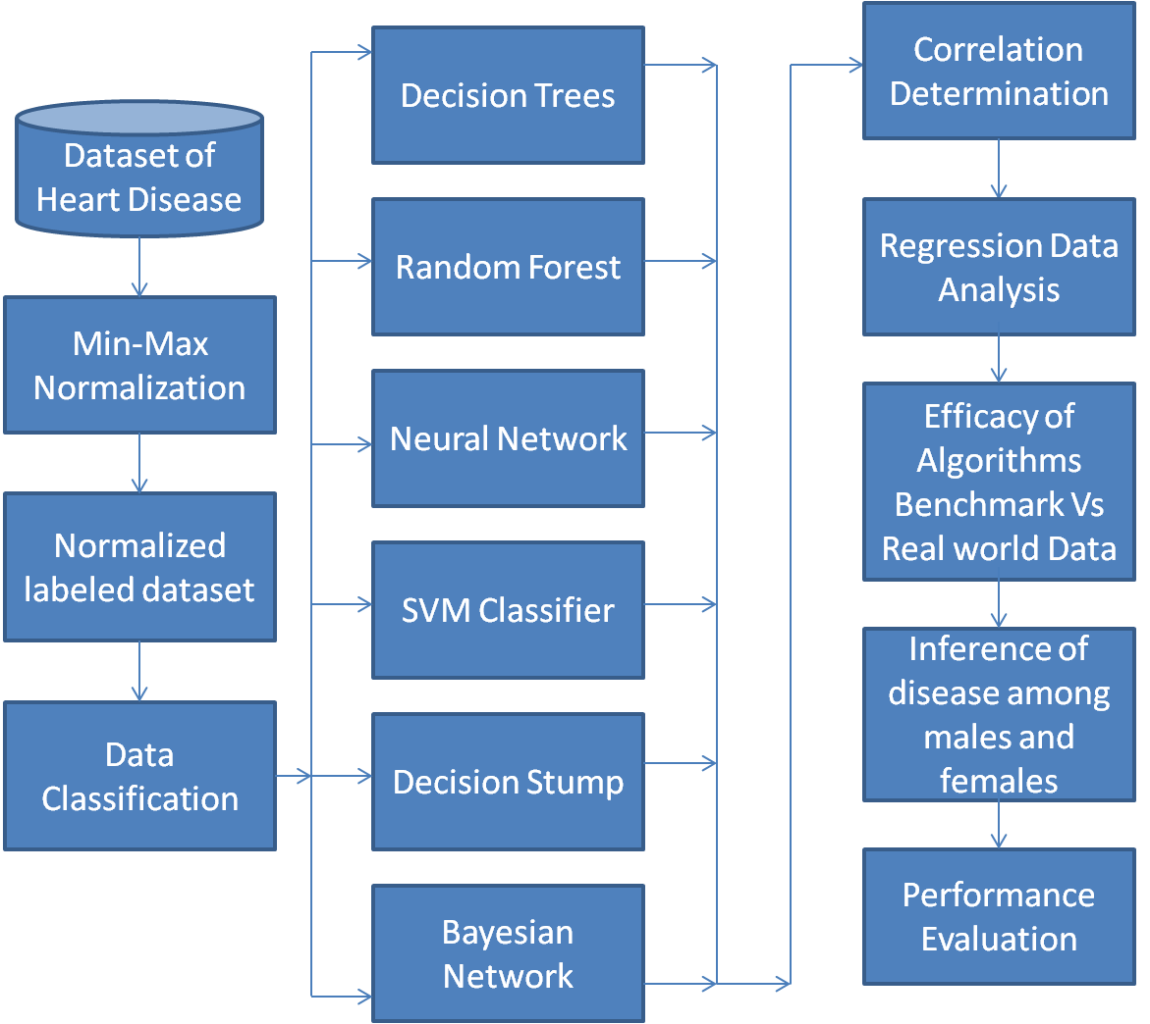

Figure 1. Methodological workflow

5.1 Metrics used for Evaluating Data Classification Performance
In this approach, the classification accuracy rates for the datasets were measured. For example, in the classification problem with two-classes, positive and negative, a single prediction has four possibilities. The True Positive rate (TP) and True Negative rate (TN) are correct classifications. A False Positive (FP) occurs when the consequence is incorrectly predicted as positive while it is truly negative. A False Negative (FN) occurs when the consequence is incorrectly predicted as negative when it is actually positive. The illustration is given in Table 3.
Table 3. Confusion Table
Prediction  level |  | Disease category
 |  | + | -
Test rate | + | True Positive Rate (TP) | False Positive Rate (FP)
Test rate | - | False Negative Rate (FN) | True Negative Rate (TN)
- Accuracy - It refers to the total number of records that are correctly classified by the classifier as given in equation 6 as follows,
(6)
- Classification error - This refers to the misclassified datasets from the correctly classified records.
- True Positive Rate (TP): It corresponds to the number of positive examples that have been correctly predicted by the classification model.
- False Positive Rate (FP): It corresponds to the number of negative examples that have been wrongly predicted by the classification model.
- Kappa Statistics - A measure of the degree of non-random agreement between observers or measurements of the same categorical variable.
- Precision - is the fraction of retrieved instances
- Recall - is the fraction of relevant instances.
- Root-Mean-Squared-error - It is a numerical value of measurement of the degree of a varying quantity. It can be intended for a sequence of distinct values or in place of a continuously varying function.
Since the class label prediction is of multi-class, the result on the test set will be displayed as a two-dimensional confusion matrix. Every matrix element shows the number of test cases for which the definite class is the row and the anticipated class is the column.

6. Results and Discussion
6.1 Classification algorithms performance over the observed data
The evaluation proceeds with classification algorithms such as C4.5 Decision tree, Random Forest, Neural Network, SVM Classifier, Decision Stump and Bayesian Network Classifier. Decision tree classification algorithm is a robust algorithm which avoids over fitting and has the capability to deal with continuous data and missing data values. The algorithm uses heuristics for pruning based on the statistical consequence of splits. The Decision tree classification algorithm uses gain ratio as the splitting criterion and the pruned tree is constructed based upon pre-pruning and post-pruning. Pre-pruning makes a branch stop growing when the information becomes unreliable. Meanwhile post pruning involves the mechanism of considering a fully grown tree and discarding the unreliable branches.
In general, random forest algorithm has the ability of handling very large data with numerous input variables. The working of the algorithm produces an internal impartial error rate as the trees generates. The algorithm has an efficient method for evaluating the data with missing records across its fields with managed accuracy levels. Neural Network models provide a much of interpretations that can be observed from learning of the trained samples. The model clearly provides the features of input parameters and its distributions. The weight assignments provide the complete formulation and simulation over the trained network.

Decision trees represent a flow-chart tree like structure which follows the divide and conquer strategy the tree proceeds from the root to the leaf node until all the branches ends up with an terminating leaf condition. In evaluation with large datasets the tree produces a complex form of representation with accordance to the attribute level too. The time complexity of decision tree algorithm rapidly increases with respect to the height of the tree. If the height of the tree increases the rate of error during testing phase decreases with an inclusion of noise in the data. The observed tree seems to be the fitted one which doesn’t indulge for the evaluation in testing. At certain cases over fitting of the data over the tree may occur which has to be reduced by the tree estimates. The working of the random forest algorithm has been observed to vary with the other algorithm which then over fits the obsolete level. Meanwhile data interpretation using random forest algorithm seems to be difficult when compared to other classification algorithm. Parallel processing computation in neural network algorithm can be adhered with variable solutions in which problems with multiple constraints are solved recursively. The neural network model with improved estimation involves 500 cycles of iteration with 0.3 to be the learning rate and momentum value with 0.2 epsilon error which is explained in equation 9 as,
(9)

The experimental results signify the mechanism of risk interaction in accordance with different events related to CHD. The performance measures of of all the algorithms is provided in table 4 for UCI data and in table 5 for real world data observed from the hospital.

6.2 Performance measurement
The effectiveness among the algorithm has been evaluated using UCI repository dataset which contains 13 attributes and real dataset containing of 24 attributes. The attributes involved are age, sex, chest pain type, serum cholesterol, fasting blood sugar, resting electro cardio graphic results, maximum heart rate achieved, exercise tempted angina, ST depression, the foremost vessels colored by means of fluoroscopy, and thal for benchmark dataset. For real dataset which has been collected from an hospital has the attributes involved are age, sex, chest pain type, systolic blood pressure, diastolic blood pressure, serum cholesterol, fasting blood sugar, restecg, weight, waist circumference, smoking, hypertension, hyper-cholesterol, previous angina, prior stroke, antero-lateral, antero-septal, infero-lateral, infero-septal, septo-anterio, diabetes, obesity, family history, pericardial effusion.
Table 4. Performance Evaluation values obtained for the algorithms for the UCI repository dataset.
Performance Measures | Decision Tree | Random Forest | Neural  Network | Support Vector Machines | Decision Stump | Bayesian network classifier
Accuracy (%) | 50.67 | 63.33 | 60.00 | 58.72 | 52.01 | 89.63
True Positive Rate | 0.507 | 0.633 | 0.600 | 0.587 | 0.520 | 0.897
False Positive Rate | 0.230 | 0.254 | 0.184 | 0.213 | 0.455 | 0.157
Precision | 0.478 | 0.570 | 0.568 | 0.516 | 0.345 | 0.805
Recall | 0.507 | 0.633 | 0.600 | 0.587 | 0.520 | 0.788
Classification Error (%) | 49.32 | 36.66 | 40.00 | 41.27 | 47.98 | 10.37
Kappa Statistics | 0.211 | 0.354 | 0.329 | 0.3126 | 0.059 | 0.830
RMS Error | 0.404 | 0.313 | 0.320 | 0.3612 | 0.338 | 0.315

Table 5. Performance Evaluation values obtained for the algorithms for the dataset obtained from the hospital.
Performance Measures | Decision Tree | Random Forest | Neural  Network | Support Vector Machines | Decision Stump | Bayesian network classifier
Accuracy (%) | 48.69 | 46.73 | 64.26 | 52.28 | 53.26 | 64.28
True Positive Rate | 0.487 | 0.467 | 0.642 | 0.522 | 0.532 | 0.643
False Positive Rate | 0.252 | 0.272 | 0.460 | 0.267 | 0.122 | 0.465
Precision | 0.485 | 0.469 | 0.622 | 0.520 | 0.552 | 0.629
Recall | 0.487 | 0.467 | 0.621 | 0.570 | 0.547 | 0.643
Classification Error (%) | 51.30 | 53.26 | 35.74 | 47.71 | 46.73 | 35.71
Kappa Statistics | 0.254 | 0.210 | 0.187 | 0.249 | 0.162 | 0.186
RMS Error | 0.460 | 0.398 | 0.483 | 0.385 | 0.397 | 0.481

In accordance with the UCI repository dataset the prediction accuracy obtained by Bayesian network classifier has found to be the highest when compared to the other algorithms as described in table 4. Whereas, in determining the prediction accuracy for the real world data the performance of neural network and Bayesian network algorithm has found to be the highest when compared to other algorithms as mentioned in table 5. Therefore, neural network and Bayesian algorithm determines the prediction accuracy to the highest level over medical data. Hence both these algorithms can be deployed over medical informatics problems in determination of medical risk analysis, predictive measures over cost impacts, probability of estimation of disease specific syndromes.
The Neural Network model represents a hidden layer with sigmoid category and scope (number of attributes + number of classes) / 2 + 1. If only a single layer without nodes is specified, the input nodes are directly linked to the output nodes and no hidden layer will be used. The castoff activation function is the normal sigmoid function. Hence, the values ranges of the attributes should be scaled to -1 and +1. The type of the output node is sigmoid if the learning data describes a classification task and linear for numerical regression tasks.

7. Statistical inference using correlation and regression analysis

7.1 Result Analysis for the UCI repository and Real world dataset
The attributes corresponding to the each sort of class label has a correlation among one another. To determine the degree of relationship between the set of attributes correlation is used to predict the statistical inference. The method of correlation is defined as the modification in one variable results a positive or negative change in the another variable and also bigger change in one variable may results up in its corresponding greater or minimal change with respect to the another variable (T.Hastie et al, 2001). In our dataset the correlation has to be determined for 13 attributes and for 24 attributes with respect to the class label. The co-efficient of correlation is denoted by ‘r’ which ranges from and if the correlation is perfect and positive then the value of r=1 and it is perfect and negative if r=-1 hence both the variables increase or decrease in same fraction. If X and Y are the two variables whose correlation is to be determined then the equation for determination of correlation becomes is given in equation 10 as,
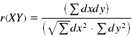 (10)
Where,
The observation of the co-efficient values for the attributes signifies to be positively correlated among the set of attributes which seems to be perfect and significant. The determination of the values of co-efficient for the set of attributes is illustrated in table 6. The nature of correlation is found to be linear with respect to the set of determined attributes.
Table 6. Correlation values determined for the 13 set of attribute with its data tuples
age | 1.00 | -.09 | 0.11 | 0.29 | 0.20 | 0.13 | 0.15 | -.39 | 0.10 | 0.20 | 0.16 | 0.36 | 0.13
sex | -.09 | 1.00 | 0.01 | -.07 | -.20 | 0.04 | 0.03 | -.06 | 0.14 | 0.10 | 0.03 | 0.09 | 0.38
cp | 0.11 | 0.01 | 1.00 | -.04 | 0.07 | -.06 | 0.06 | -.34 | 0.38 | 0.20 | 0.15 | 0.24 | 0.27
trestbps | 0.29 | -.07 | -.04 | 1.00 | 0.13 | 0.18 | 0.15 | -.05 | 0.07 | 0.19 | 0.12 | 0.10 | 0.14
chol | 0.20 | -.20 | 0.07 | 0.13 | 1.00 | 0.01 | 0.16 | 0.00 | 0.06 | 0.04 | -.01 | 0.12 | 0.01
fps | 0.13 | 0.04 | -.06 | 0.18 | 0.01 | 1.00 | 0.07 | -.01 | 0.00 | 0.01 | 0.05 | 0.15 | 0.06
restecg | 0.15 | 0.03 | 0.06 | 0.15 | 0.16 | 0.07 | 1.00 | -.07 | 0.08 | 0.12 | 0.14 | 0.13 | 0.02
thalach | -.39 | -.06 | -.34 | -.05 | 0.00 | -.01 | -.07 | 1.00 | -.39 | -.35 | -.39 | -.27 | -.28
exang | 0.10 | 0.14 | 0.38 | 0.07 | 0.06 | 0.00 | 0.08 | -.39 | 1.00 | 0.29 | 0.25 | 0.15 | 0.33
oldpeak | 0.20 | 0.10 | 0.20 | 0.19 | 0.04 | 0.01 | 0.12 | -.35 | 0.29 | 1.00 | 0.58 | 0.30 | 0.35
slope | 0.16 | 0.03 | 0.15 | 0.12 | -.01 | 0.05 | 0.14 | -.39 | 0.25 | 0.58 | 1.00 | 0.11 | 0.28
ca | 0.36 | 0.09 | 0.24 | 0.10 | 0.12 | 0.15 | 0.13 | -.27 | 0.15 | 0.30 | 0.11 | 1.00 | 0.26
thal | 0.13 | 0.38 | 0.27 | 0.14 | 0.01 | 0.06 | 0.02 | -.28 | 0.33 | 0.35 | 0.28 | 0.26 | 1.00

The observed diagonal values obtained seems to have the value of +1 which give the impression of positive correlation for the set of attributes with the class labels at five distinct separations. Similarly the weight values for the set of all the attributes as illustrated in table 7 as follows:

Table 7. Weighted set of attributes after correlation analysis.

Attribute name | Weight values
age | 0.17
sex | 0.34
cp | 0.25
trestbps | 0.19
chol | 0.34
fps | 0.28
restecg | 0.24
thalach | 1.00
exang | 0.14
oldpeak | 0.00
slope | 0.13
ca | 0.08
thal | 0.02

The weighted results show that the attribute thalach, cholesterol levels seems to have higher weight values than that of the other attributes. Similarly the correlation analysis for the 24 attributes with its class label with 4 distinct separations has been determined. As per the specification criteria the correlation co-efficient values ranges between for the data levels. The following table 8 provides the weight values for the observed set of attributes at all levels. Among all the attributes the attribute chest pain type, antero-lateral, hyper cholesterol, seems to have higher impact over weights among all the attributes.

Table 8. Correlation weight determined for the 24 set of attribute with its data tuples

Attribute Name | Weight Values
age | 0.62
sex | 0.33
cptype | 0.89
sbp | 0.14
dbp | 0.08
schol | 0.56
fbs | 0.26
restecg | 0.76
weight | 0.39
wcircum | 0.42
smoke | 0.35
hypten | 0.26
hypchol | 0.83
prevangi | 0.13
Prior-stroke | 0.00
alater | 1.00
aseptal | 0.63
iseptal | 0.53
ilateral | 0.48
santerio | 0.26
diabetes | 0.32
obesity | 0.20
fhistory | 0.15
peffusion | 0.25

Similarly regression analysis has been made for the observed dataset to estimate the average value for one variable for a specified value with accordance to another variable. The regression equation for a variable X on Y is given by the equation in equation 11 as follows,
(11)
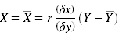 (12)
In the above equation 12 the value of r corresponds to the correlation co-efficient value which has been predetermined in the previous step. Since the computed value of r=1 the standard deviation for the x and y series alone signifies the regression for the defined variables. An experimental result shows that the attributes in table 9 corresponds to the linearity with respect to the other variables for the dispersed set of labels.

Table 9. Regression analysis with its co-efficient over UCI Repository dataset
Attribute | Regression co-efficient
sex | 0.18
cp | 0.19
restecg | 0.10
thalach | 0.00
exang | 0.24
oldpeak | 0.19
slope | 0.16
ca | 0.41
thal | 0.14
Intercept
It has been observed from the data that the males in the higher category of heart disease signification has more in number when compared to that of the females in all category of representation. The following table 10 represents the category of males and females in association with the set of distribution to the level of disease at all levels.

Table 10. Categorization of males and females with accordance to the labels for the UCI repository data.
 | Label 0 | Label 1 | Label 2 | Label 3 | Label 4
Males | 90 | 45 | 28 | 28 | 11
Females | 71 | 9 | 7 | 7 | 2
With the dispersion of data among males and females, the males have to be found very severe with the disease level at all categories. Meanwhile the females have been found to be less impact to the prevalence of heart disease than that of males.
When considering the dataset with 24 attributes the performance of a mathematical model is evaluated by the P value of the model. The p‐value for each term tests the null hypothesis that the coefficient is equal to zero no effect. A low p‐value with <0.05 indicates that the null hypothesis is rejected. In other words, a predictor that has a low p‐value is a meaningful addition to the model because changes in the predictor's value are related to changes in the response variable. Conversely, a larger insignificant p‐value suggests that changes in the predictor are not associated with changes in the response. The mathematical model with the lowest p value and limited number of attributes gives the best fit or relation between the attributes and the outcome variable (class label i.e.., the heart disease risk stage). The following table 11 provides the observed regression coefficient values determined for the attributes of real world data.

Table 11. Regression analysis with its co-efficient over real world dataset
Sl No. | Attribute | Regression Coefficient
1 | Chest pain type | 0.0237
2 | Serum cholesterol | -0.0030
3 | Restecg | 0.2823
4 | Prior stroke | 0.6940
5 | Septo-anterio | 0.2889
6 | Family history | 0.3535
7 | Pericardial effusion | 1.2478
8 | Intercept | 0.7226
As from the table 11 it has been determined that the attributes such as chest pain type, serum cholesterol, restecg, prior stroke, septo anterio, family history, pericardial effusion, has found to be the most predominant factors with accordance to the weight based determination over regression analysis. The categorization over male and female has been found and it has been clearly determined that the impact of the disease is largely towards the male category than that of the females as illustrated in table 12 which is of the same case over the UCI repository dataset.

Table 12. Categorization of males and females with accordance to the labels for the real world data.
 | Label 0 | Label 1 | Label 2 | Label 3
Males | 57 | 79 | 31 | 20
Females | 39 | 42 | 12 | 15

7.2 Simulation Analysis and Statistical inference over the observed attributes
The determined attributes over the benchmark and the real world data has been simulated with accordance to each level of observance against age. The following figures signify the relationship among the attributes that has major significance over the disease. from the observed analysis the age factor ranges 48 to 65 has found to be more prevalent with the major set of risk factors attained as per the weights observed from correlation and regression analysis. The figure 2, figure 3 and figure 4 determines the analysis over the benchmark dataset.
When considering the real world dataset the significance of the disease at the initial stage with chest pain type corresponds to the value 1 and the final stage is more prevalent. Mean while, the cholesterol levels for the female is found to be higher as discussed in figure 5. The analysis of family history over both male and female is found in which female cases has more predominant to the history related to the disease. From figure 4 it has been clearly observed that with the box plot a much tightened bound has been observed for the label four. It means that, the patients with higher level of heart disease have the maximum rate to be affected. With the labels of one and two there seems to be observed outliers which signifies that age alone is not a factor for the pre-determination of heart disease.
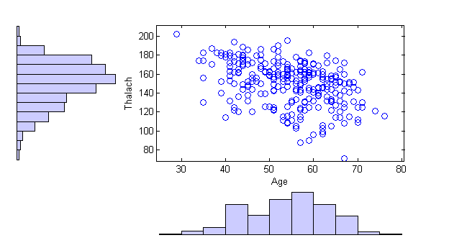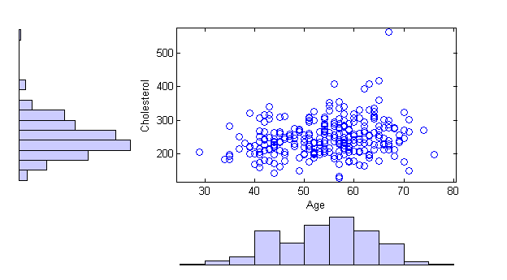
Figure 2 Analysis over age, thalach and cholesterol levels for benchmark dataset
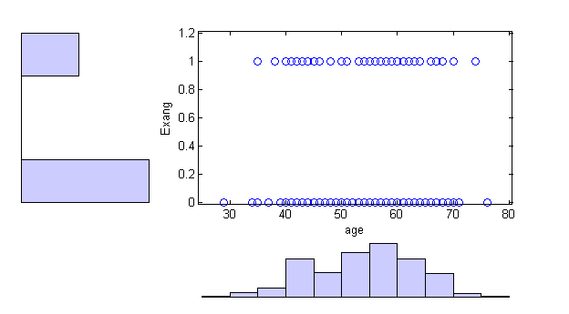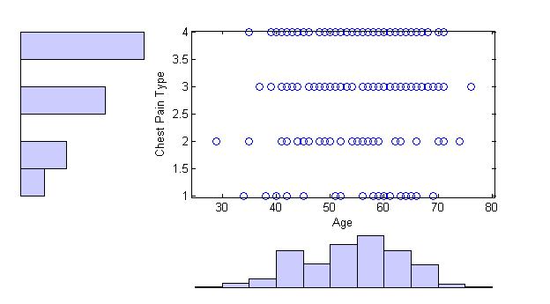
Figure 3 Analysis over age, exang and chest pain type for benchmark dataset
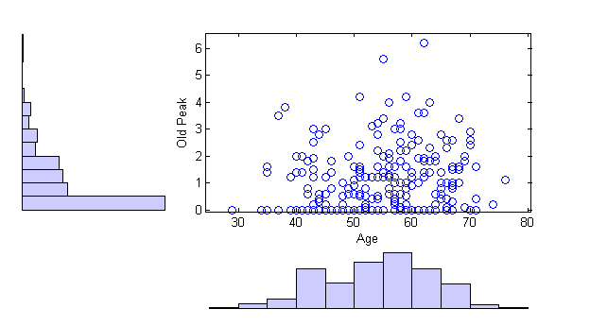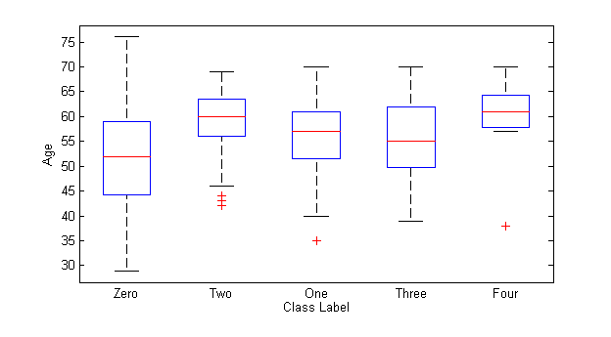
Figure 4 Analysis over age, old peak for benchmark dataset with estimation for class label
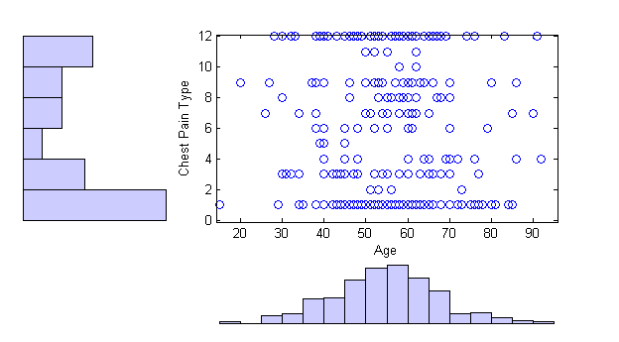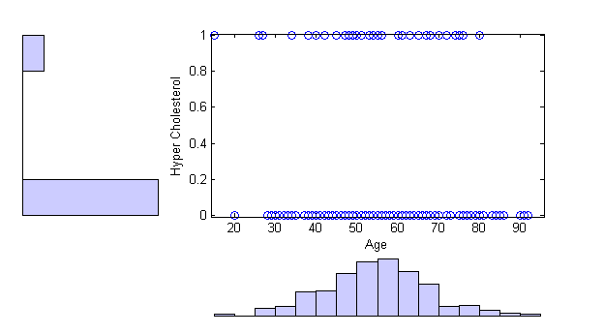
Figure 5 Analysis over age, Hyper Cholesterol and chest pain type for real dataset

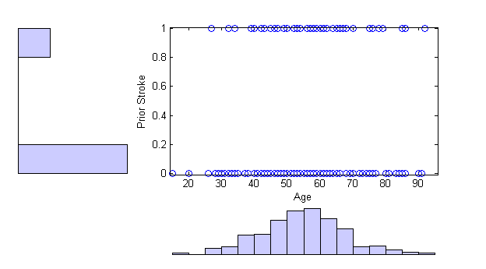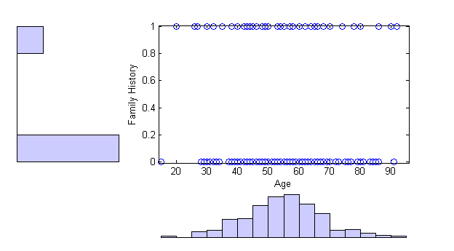
Figure 6 Analysis over age, prior stroke and family history for real dataset
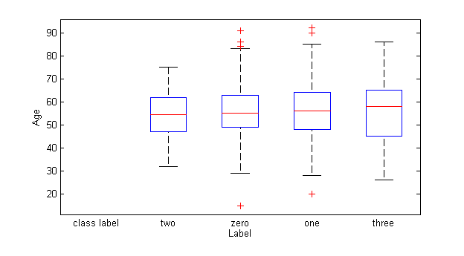
Figure 7 Analysis of age with label values for real world data

From figure 7 it has been observed that for labels zero, one and three there seems to be a wide range of relaxation for the level of heart disease with respect to the age factor. The age group corresponding to 48-59 seems to be more prevalent with the disease. To justify the conclusion mathematical significance has been observed for the selected variables in accordance with the class label (J H Bennett, 1989).

Conclusion and future work
Data analytics and prediction has been concerned with the determination and prediction of risk related to different diseases. This paper is mainly concerned with the investigation of various classification algorithms such as Decision tree, Random Forest, Neural Network, Support Vector Machines, Decision Stump and Bayesian network classifier for determining the predictive performance analysis in medical data. The investigation is further preceded by the determination of the risk factors with the weight values based on correlation and regression analysis. The inference of statistical significance has also been determined using correlation and regression analysis which shows the data tuples are significant and positively correlated.
While considering correlation analysis over both of the dataset thalach and cholesterol are the predominant risk factors over UCI dataset and chest pain type, antero-lateral, hyper-cholosterol, are the determined risk factors over real world dataset. Similarly the mechanism of risk factor analysis has been made to both the datasets using regression analysis for UCI dataset the risk determined are exang, chest pain type, old peak and for the real world dataset the risk factors determined are chest pain type, restecg, prior stroke, septo anterio, family history and pericardial effusion. As an inference for both of the dataset, the predominantly and commonly determined risk factors are cholesterol levels, chest pain type, ECG results. The adherent factors are thalach, prior stroke, family history. From the results over data classifiers for the UCI repository dataset it has been shown that Bayesian network algorithm provides an improved prediction accuracy of about 89.63% and for the real world dataset Bayesian classifier with 64.28%, neural network with 64.26% when compared to other classification algorithms. Hence Bayesian network classifier, Neural Network can be greatly deployed for predictive performance measures in medical data. The ratio over both of the dataset shows that males are mostly prevalent to the specification of heart disease syndrome that that of females. The future work can be progressed with other specific disease treatment mechanisms such as diabetes, cancer classification, kidney disease occurrence and investigation with the data classification algorithms in data analytics.

References
- http://www.medicalnewstoday.com/articles/184130.php
- http://www.who.int/gho/ncd/mortality_morbidity/ncd_total_text/en/index.html
- N. Stolba and M.A Tjoa. ‘The relevance of data warehousing and data mining in the field of evidence-based medicine to support healthcare decision making’ Austrian Federal Ministry for Education, Science and Culture, (2002).
- W. Stuhlinger , O. Hogl, W. Stoyan, and M. Muller ‘Intelligent Data Mining for Medical Quality Management’, (2003).
- British Heart Foundation. European Cardio-vascular Disease Statistics, (2008).
- Z.J Zhang and S.H Wang ‘Synopsis of Prescriptions of the Golden Chamber’ Beijing: People’s Medical Publishing House, pp.27–29, (2007).
- Mohammed Danesh Zand, Amir Hossein Ansari, Caro Lucas, Reza Aghaee Zade Zoroofi, “Risk Assesment of Coronary Arteries Heart Disease based on Neuro-Fuzzy Classifiers”, Proceedings of the 17th Iranian Conference of Biomedical Engineering (ICBME2010), 3-4 November (2010).
- T.D. Rea, S.R. Heckbert, R.C. Kaplan, N.L. Smith, R.N. Lemaitre, and B.M.Psaty, “Smoking status and risk for recurrent coronary events after myocardial infarction” Ann. Int. Med., vol. 137, pp. 494-500, (2002).
- Z. Wang and W.E. Hoy “Is the Framingham coronary heart disease absolute risk function applicable to Aboriginal people?” Med.J.Australia, Vol.182, No. 2, pp. 66-69, (2005).
- K. Srinivas, G. Raghavendra, Rao, and A. Govardhan, “Analysis of Coronary Heart Disease and Prediction of Heart Attack in Coal Mining Regions Using Data Mining Techniques”, 5th IntConf on Computer Science & Education Hefei, China, pp. 1344-1349, (2010).
- C.Ordonez, “comparing association rules and decision trees for disease prediction”, in proceedings of the International Conference on Knowledge management, Arlington, (2006). PP. 17-24.
- Xue-Hui Meng, Yi-Xiang Huang, Dong-Ping Rao, Qiu Zhang, Qing Liu, “Comparison of three data mining models for predicting diabetes or prediabetes by risk factors”, Kaohsiung Journal of Medical Sciences Volume.29, pp.93-99, Elsevier, (2013).
- Seyed Abdolmotalleb Izad Shenas, Bijan Raahemi, Mohammad Hossein Tekieh, Craig Kuziemsky, “Identifying high-cost patients using data mining techniques and a small set of non-trivial attributes”, Computers in Biology and Medicine volume.53 pp. 9–18, Elsevier, (2014).
- http://archive.ics.uci.edu/ml/datasets/Heart+Disease.
- A. Karaolis, A. Moutiris, D. Hadjipanayi, S. Pattichis, “Assessment of the Risk Factors of Coronary Heart Events Based on Data Mining With Decision Trees”, IEEE transactions on information technology in biomedicine, vol. 14, no. 3, may (2010).
- S. Chang-Sik et al, “Decision-making model for early diagnosis of congestive heart failure using rough set and decision tree approaches”, Journal of Biomedical Informatics Volume 45, pp. 999–1008, 2012.
- L.Breiman, “Random Forests”, Machine Learning 45, no.1:5-32,(2001).
- P.S. Wasan et al,”Application of statistics and machine learning for risk stratification of heritable cardiac arrhythmias”, Expert Systems with Applications Volume 40, pp.2476–2486, (2013).
- C. Peter et al, “Using methods from the data-mining and machine-learning literature for disease classification and prediction: a case study examining classification of heart failure subtypes”, Journal of Clinical Epidemiology (2013).
- N.Christianini and J.S.Taylor, “An Introduction to support vector machines and other kernel based learning methods”, Cambridge university press, 2000.
- Jiawei han and micheline kamber, “Data Mining Concepts and techniques”, third edition, (2010).
- T.Hastie, R.Tibshrani and J.Friedman, “Elements of statistical learning: Data mining, Inference and prediction”, Springer Verlag, Berlin, Germany, (2001).
- Bailey, R. A. Design of Comparative Experiments. Cambridge University Press. ISBN 978-0-521-68357-9. (2008).
- J H Bennett (ed.), Statistical inference and analysis: selected correspondence of R A Fisher (Oxford, 1989).
- Cortina, J. M., & Nouri, H. Effect size for ANOVA designs. Thousand Oaks, CA: Sage Publications. Effect Size for ANOVA Designs (Quantitative Applications in the Social Sciences) (2000).
- Turner, J. R., & Thayer, J. F. (2001). Introduction to analysis of variance: Design, analysis, & interpretation. Thousand Oaks, CA: Sage Publications.
- Kunc,J. Drinovec,S. Rucigaj, Mrhar A. (2010), “Simulation analysis of coronary heart disease, congestive heart failure and end-stage renal disease economic burden." Mathematics and computers in simulation.
- British Heart Foundation. European Cardio-vascular Disease Statistics, 2008.
- Z.J Zhang and S.H Wang (2007) ‘Synopsis of Prescriptions of the Golden Chamber’ Beijing: People’s Medical Publishing House, pp.27–29,
- Tsien C.L., Fraser H.S.F, Long W.J., and Kennedy R.L (2001) ‘Using classification trees and logistic regression methods to diagnose myocardial infarction’ in Proc. 9th World Congr., Inf., vol. 52, pp. 483-497.

